**Test Case** **0045**

**System:** VirtuCardsClient & VirtuCardsHost

**Description:** Test that the host can play a new game after ending it

**Severity:** 3

**Instructions**

**Test 1**

1. Start VirtuCardClient application
2. Click the button labeled “Sign In”
3. Enter “gamer1@gmail.com” into the text input labeled “Enter email…”
4. Enter “CS30700” into the text input labeled “Enter password…”
5. Press the button labeled “Login”
6. A window should appear saying “Login Success”
7. Press the OK button that appears on that window
8. Start VirtuCardHost application
9. Click the button labeled “Sign In”
10. Enter “micro@soft.com” into the text input labeled “Enter email…”
11. Enter “Password!123” into the text input labeled “Enter password…”
12. The checkbox “Allow Host to Join” should be checked on the host
13. On the dropdown select test game as the gamemode
14. Press the Create Game Button
15. On the client enter the join code and click “Join Game”
16. Once the client is in the game, start the game on the host side.
17. On the host side, click the “End Game” button.

**Expected Result:** The End Game panel should display

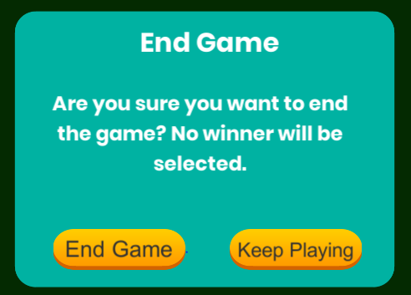

* This is what the end game panel should display

1. Click End Game again to confirm

**Expected Result:** A new panel should show up on the host giving the host the option to play again, and a message should be displayed on the client side.

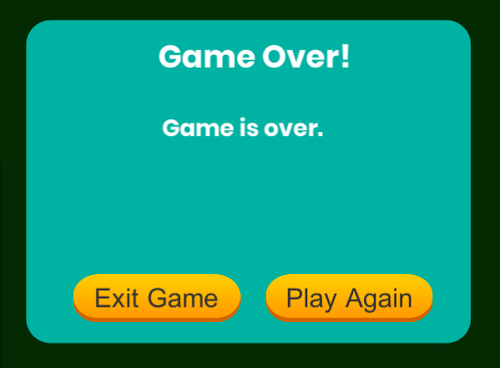

* Here is what should be displayed on the Host side

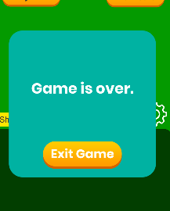

* Here is the message panel that the client should have

1. Now on the host side click play again

**Expected Result:** Now both the client and the host should be back to the regular game screen.

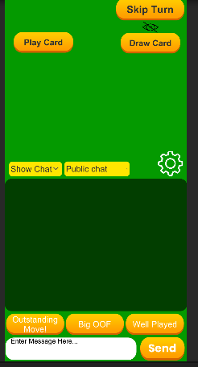

* When the host clicks play again all players in the game will be automatically redirected back to the playing screen

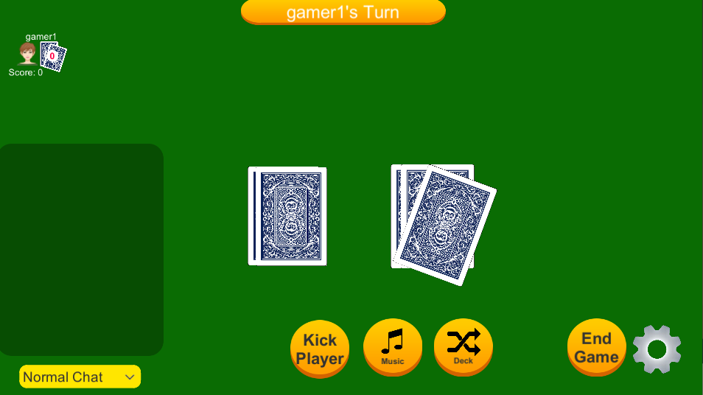

* When the host clicks play again this is what the screen should go back to

**Instructions**

**Test 2**

1. Start VirtuCardClient application
2. Click the button labeled “Sign In”
3. Enter “gamer1@gmail.com” into the text input labeled “Enter email…”
4. Enter “CS30700” into the text input labeled “Enter password…”
5. Press the button labeled “Login”
6. A window should appear saying “Login Success”
7. Press the OK button that appears on that window
8. Start VirtuCardClient application
9. Click the button labeled “Sign In”
10. Enter “gamer2@gmail.com” into the text input labeled “Enter email…”
11. Enter “CS30700” into the text input labeled “Enter password…”
12. Press the button labeled “Login”
13. A window should appear saying “Login Success”
14. Press the OK button that appears on that window
15. Start VirtuCardHost application
16. Click the button labeled “Sign In”
17. Enter “micro@soft.com” into the text input labeled “Enter email…”
18. Enter “Password!123” into the text input labeled “Enter password…”
19. The checkbox “Allow Host to Join” should be checked on the host
20. On the dropdown select test game as the gamemode
21. Press the Create Game Button
22. On both clients enter the join code and click “Join Game”
23. Once the client is in the game, start the game on the host side.
24. On the host side, click the “End Game” button.

**Expected Result:** The End Game panel should display



* This is what the end game panel should display

1. Click End Game again to confirm

**Expected Result:** A new panel should show up on the host giving the host the option to play again, and a message should be displayed on the client side.



* Here is what should be displayed on the Host side



* Here is the message panel that both clients should have

1. Now on the host side click play again

**Expected Result:** Now both the client and the host should be back to the regular game screen.



* When the host clicks play again all players in the game will be automatically redirected back to the playing screen

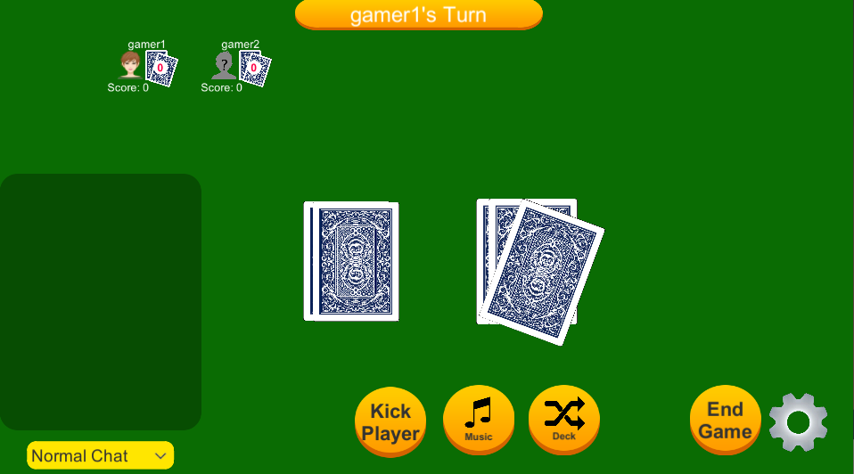

* The host screen should be reset to look like this after play again has been clicked

**Instructions**

**Test 3**

1. Start VirtuCardClient application
2. Click the button labeled “Sign In”
3. Enter “gamer1@gmail.com” into the text input labeled “Enter email…”
4. Enter “CS30700” into the text input labeled “Enter password…”
5. Press the button labeled “Login”
6. A window should appear saying “Login Success”
7. Press the OK button that appears on that window
8. Start VirtuCardHost application
9. Click the button labeled “Sign In”
10. Enter “micro@soft.com” into the text input labeled “Enter email…”
11. Enter “Password!123” into the text input labeled “Enter password…”
12. The checkbox “Allow Host to Join” should be checked on the host
13. On the dropdown select test game as the gamemode
14. Press the Create Game Button
15. On the client enter the join code and click “Join Game”
16. Once the client is in the game, start the game on the host side.
17. On the client, click the “Draw Card” button three times

**Expected Result:** The client should now have three new cards in their hand and on the host screen their profile display should show that they now have three cards

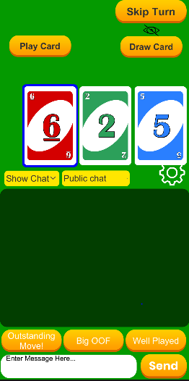

* Here you can see that the client has three new cards

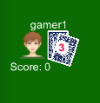

* On the host screen you can now see that gamer1 has three cards

1. Now on the client side click the “Play Card” button

**Expected Result:** The client should not have that card anymore and the host should show that card on the played card pile on their screen

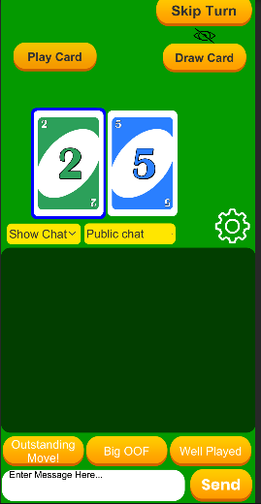

* Here is the client after playing a card, it is not on their screen anymore

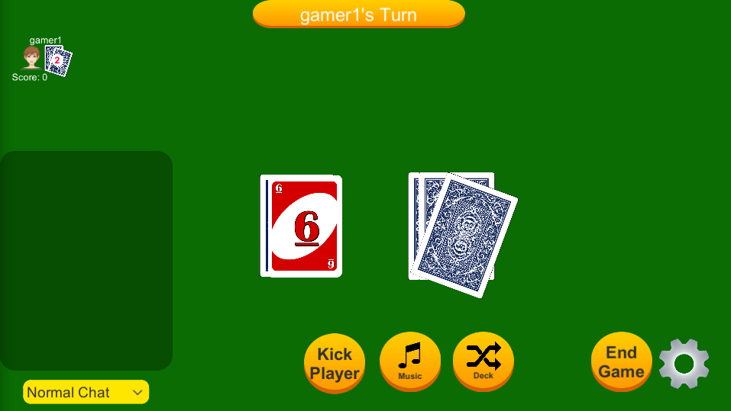

* Here you can see that host shows the card that the client played

1. On the host side, click the “End Game” button.

**Expected Result:** The End Game panel should display



* This is what the end game panel should display

1. Click End Game again to confirm

**Expected Result:** A new panel should show up on the host giving the host the option to play again, and a message should be displayed on the client side.



* Here is what should be displayed on the Host side



* Here is the message panel that the client should have

1. Now on the host side click play again

**Expected Result:** The client’s hand should be cleared, the host should reset gamer1’s card count to 0 and the last played card should be cleared.



* When the host clicks play again all players in the game will be automatically redirected back to the playing screen



* When the host clicks play again everything is reset. Gamer1’s score, and the last played card should be updated to be face down.

**Instructions**

**Test 4**

1. Start VirtuCardClient application
2. Click the button labeled “Sign In”
3. Enter “gamer1@gmail.com” into the text input labeled “Enter email…”
4. Enter “CS30700” into the text input labeled “Enter password…”
5. Press the button labeled “Login”
6. A window should appear saying “Login Success”
7. Press the OK button that appears on that window
8. Start VirtuCardClient application
9. Click the button labeled “Sign In”
10. Enter “gamer2@gmail.com” into the text input labeled “Enter email…”
11. Enter “CS30700” into the text input labeled “Enter password…”
12. Press the button labeled “Login”
13. A window should appear saying “Login Success”
14. Press the OK button that appears on that window
15. Start VirtuCardHost application
16. Click the button labeled “Sign In”
17. Enter “micro@soft.com” into the text input labeled “Enter email…”
18. Enter “Password!123” into the text input labeled “Enter password…”
19. The checkbox “Allow Host to Join” should be checked on the host
20. On the dropdown select test game as the gamemode
21. Press the Create Game Button
22. On both clients enter the join code and click “Join Game”
23. Once the client is in the game, start the game on the host side.
24. Whichever client is first should click draw card three times

**Expected Result:** Three cards should be drawn to that player’s hand

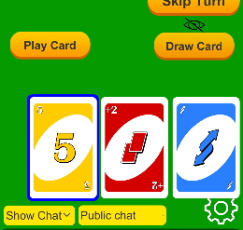

* Here is what gamer1’s hand should look like



* Here is what should be displayed on the host side

1. On the other client click draw card three time

**Expected Result:** Three cards should be drawn to that player’s hand

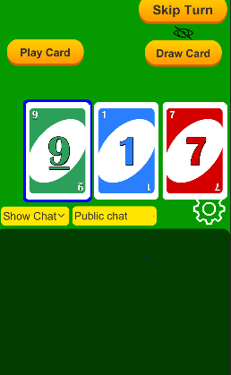

* This is what the client should display, and the host screen should be updated accordingly

1. Now click play card on the card selected

**Expected Result:** The last played card should be shown face up on the host side



* This shows that last played card

1. On the host side, click the “End Game” button.

**Expected Result:** The End Game panel should display



* This is what the end game panel should display

1. Click End Game again to confirm

**Expected Result:** A new panel should show up on the host giving the host the option to play again, and a message should be displayed on the client side.



* Here is what should be displayed on the Host side



* Here is the message panel that both clients should have

1. Now on the host side click play again

**Expected Result:** Now both the client and the host should be back to the regular game screen.



* When the host clicks play again all players in the game will be automatically redirected back to the playing screen



* The host screen should be reset to look like this after play again has been clicked